

**SECONDARY SALES SYSTEM**

**(DOCUMENT SIGNOFF)**

Dated: 16-12-2024

**Pre-Sell Workflow**

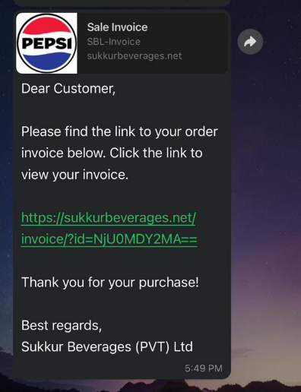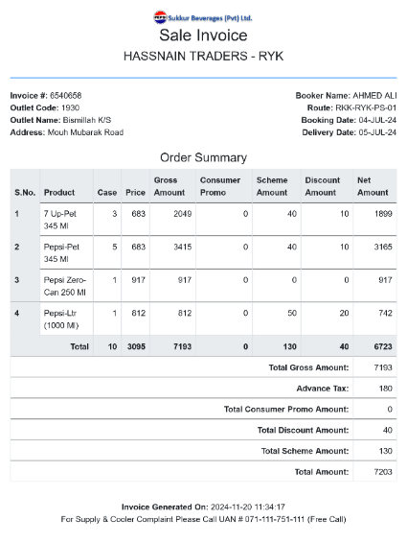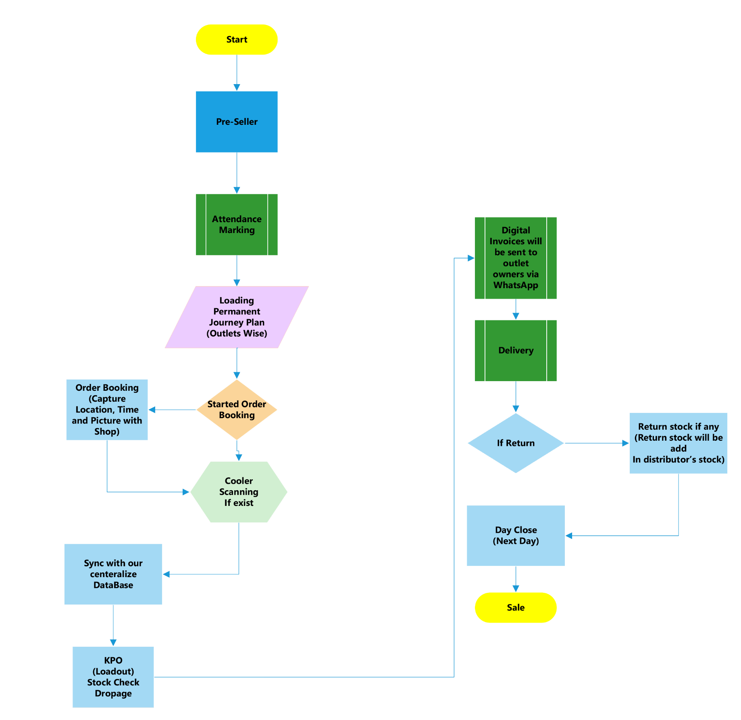

**(Note: Distributor is either Pre-Sell or Spot Sale, it cannot be both)**

# Step 1: Pre-sale Day Start

* Using the mobile app, the pre-seller will mark attendance at the designated distributor location.
* The pre-seller will download their journey plan onto the app. (Note: Both attendance marking and journey plan download will be conducted online.)
* A pre-seller/booker has only one route at a time

# Step 2: Order Booking

* The pre-seller will visit each outlet within a 50-meter geo-fence radius to take orders.
* Orders will be synced manually at three specific slots for smooth operations and performance monitoring:
  + 1st Slot: 12:00 PM
  + 2nd Slot: 3:00 PM
  + 3rd Slot: 6:00 PM

# Step 3: Lead-out Generation at KPO side

* The KPO will view the day’s orders on desktop software and generate load-outs for each booker, organized outlet-wise.
* Stock availability will be verified during load-out generation, and any shortages or adjustments will be calculated.
* The KPO will have the option to change the delivery date if a holiday is scheduled.

# Step 4: Order Delivery

On the following day, the KPO will print invoices and dispatch the load-outs for delivery. Additionally, a digital invoice will be sent to all the outlets that placed orders via WhatsApp.

# Step 5: Sale Return/Final Settlement

* On the day of dispatch, the KPO will process any sale returns upon the delivery man’s return.
* After the final settlement, the day’s records will be locked by the system and cannot be modified.

**Spot Sale Workflow**

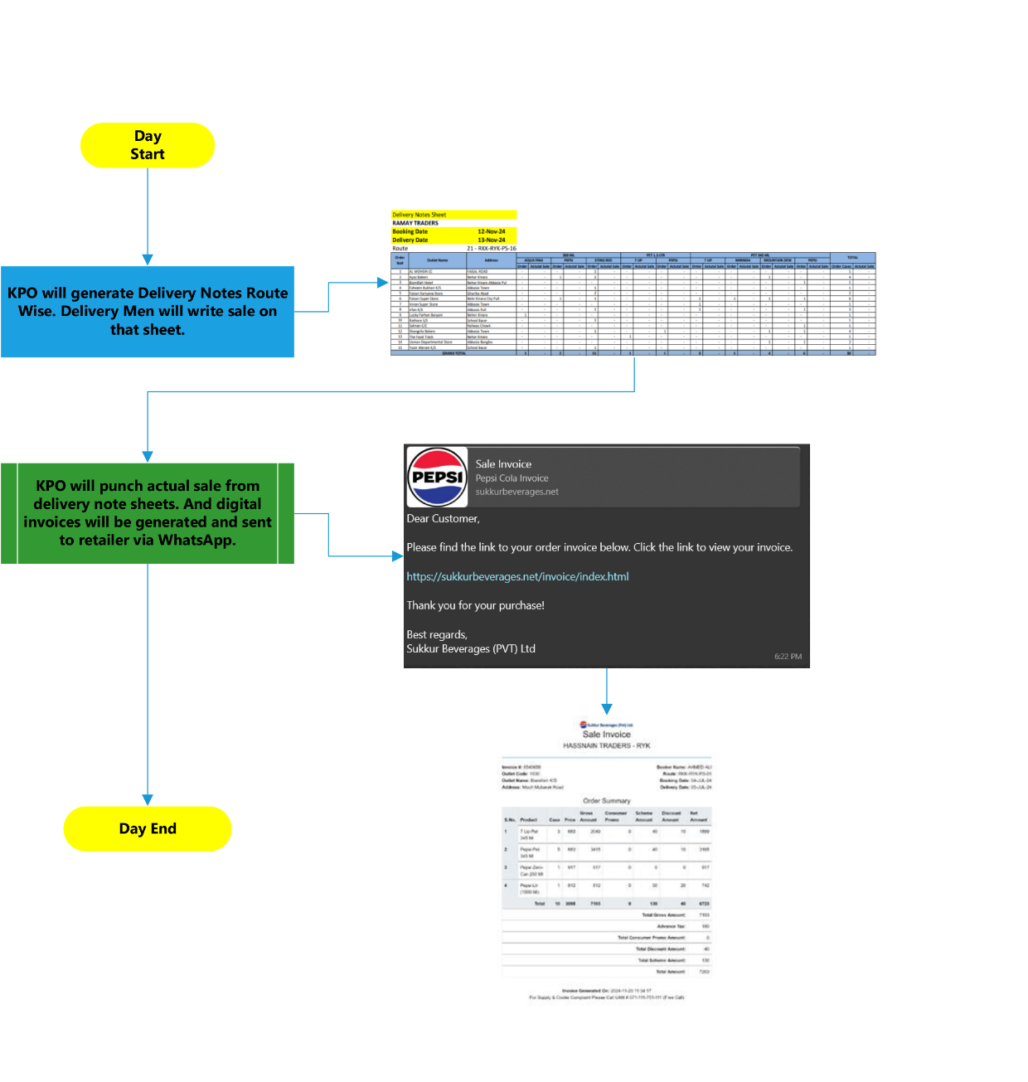**Option 1 (Using Delivery Notes Sheet)**

# Sale Punching

The he KPO will record spot sales in the system based on the delivery man’s Delivery Note Sheets. A digital invoice will then be sent to the retailer via WhatsApp.

**Spot Sale Workflow**

**Option 2 (Using Mobile App)**

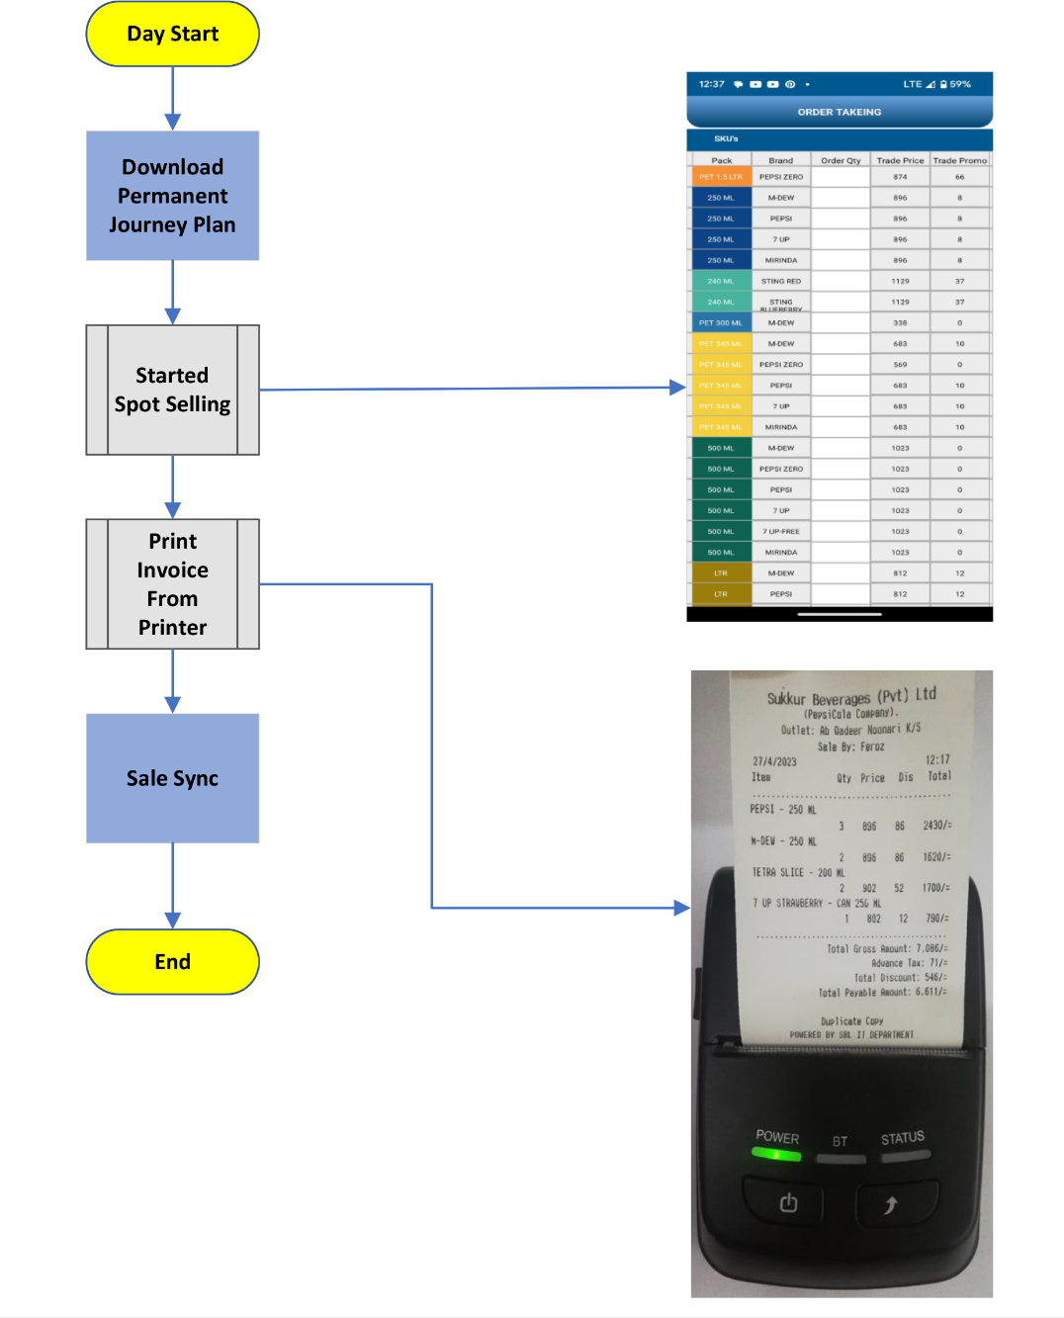

# Sale Punching

The delivery personnel will download the Permanent Journey Plan (PJP), perform outlet-wise sales punching in the mobile application, and generate invoices for retailers using a thermal pocket printer.

**Wholesale**

Note: Wholesale transactions can be categorized as either pre-sale or spot sale, following the same workflow as applicable to pre-sale and spot sale processes.

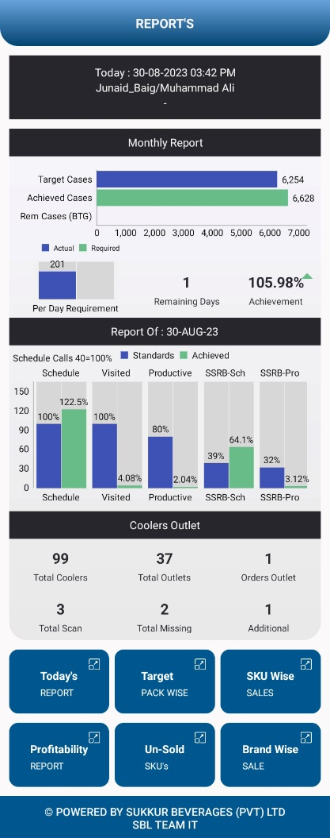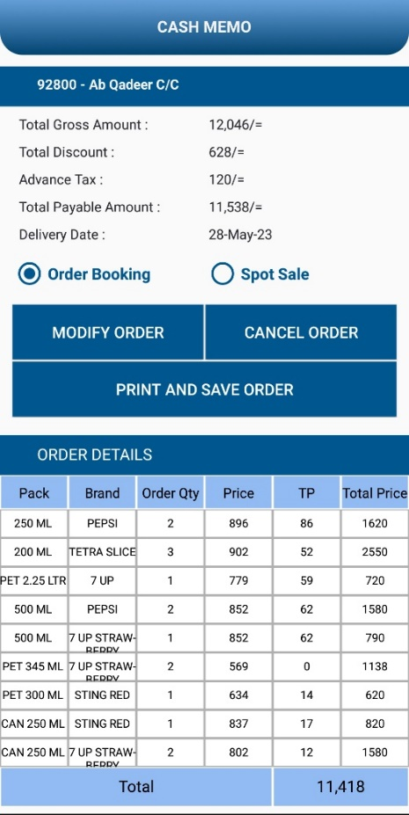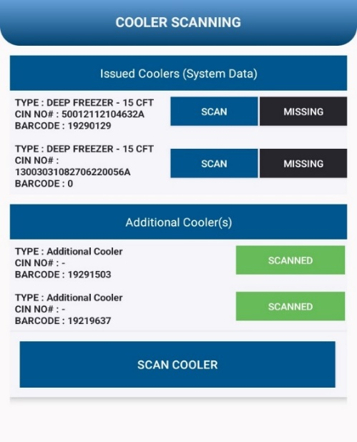**Mobile App**

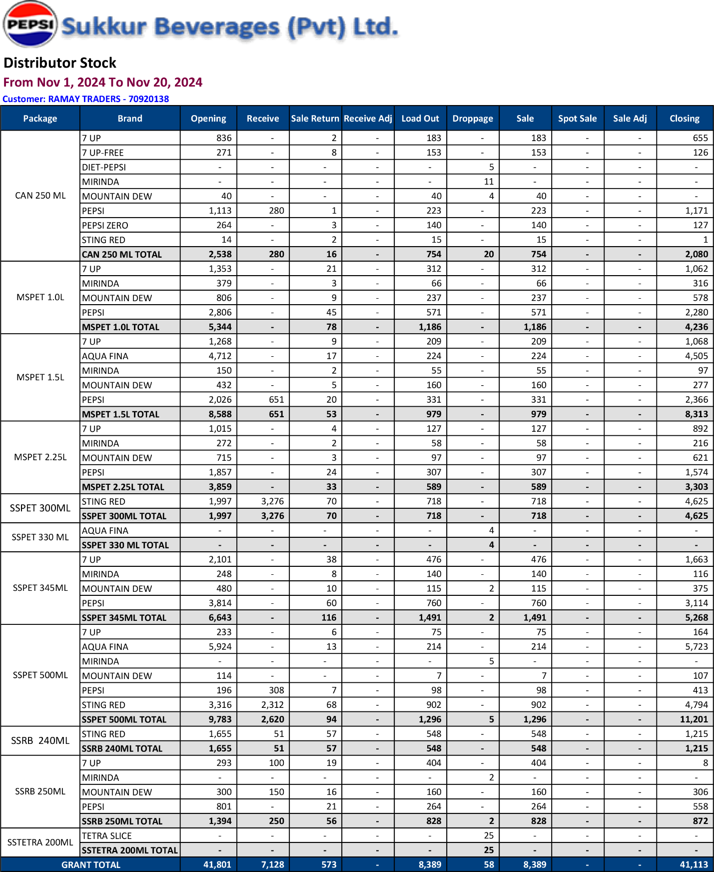Reports and Dashboard

# 

# 

# **Software Requirements Signoff**

By signing below, all stakeholders confirm their review and agreement with the outlined software requirements. This signoff signifies mutual understanding and approval to proceed with the proposed solution.

­Sign: _________________

**Mr. Nadeem Irshad**

Head of Sale

­Sign: _________________

**Mr. Asif Mehmood**

Chief Technology Officer

­